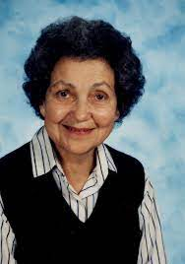
Theorist: Vivian Gussin Paley
- Who is this theorist?
  - Vivian Gussin Paley was an early childhood teacher, writer, and teacher researcher
- Where/when did they live and work?
  - She lived and taught in Chicago, U.S. 1929-2019
  - Her teaching was conducted at the University of Chicago Lab School, where she taught preschool and kindergarten for many years.
- What is their theory about play? What implications does this have for education?
  - Paley’s theory is that fantasy play and storytelling are vital to young children’s development, and that storytelling and fantasy play can significantly impact children’s social and academic growth and development.
  - Paley developed an approach known as Storytelling and Story Acting, in which children dictate stories of their choosing and then act out the stories together with their classmates.
  - In developing her theory and conducting her research, Paley acted as a teacher-researcher, collecting audio recordings and written transcripts of play episodes and conversations with children in her classroom, and then reflecting on this data to inform her writing.
- Where can I learn more?
  - By reading Paley’s books about play in the early childhood classroom, including:
    - You Can’t Say You Can’t Play (1993)
    - The Boy Who Would be a Helicopter (1991)
    - The Girl with the Brown Crayon (1997)
    - A Child’s Work: The Importance of Fantasy Play (2004)

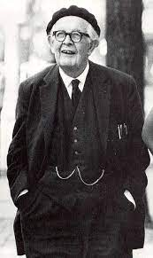
Theorist: Jean Piaget
- Who is this theorist?
  - Jean William Fritz Piaget, a psychologist and philosopher, is well known for his cognitive development theory.
- Where/when did they live and work?
  - He lived in Neuchâtel, Switzerland. 1896-1980.
  - He taught in the fields of psychology, sociology, and philosophy of science at the University of Geneva after developing his famous theory of cognitive development.
- What is their theory about play? What implications does this have for education?
  - Play as assimilation – children use play to organize their understandings of the world
  - He worked on the stages of cognitive development by observing the children’s actions and he believed that play helps children to digest mentally and to understand personal experiences.
  - His understanding of play indicates that as a child matures, their environment and play should assist them to develop their cognitive and language skills.
  - He categorized children’s play into four types; functional play, constructive play, symbolic/fantasy play, and games with rules.
  - Piaget believed that play is more than just a way for children to show their interest. Play also has one more purpose in resolving and overcoming conflict situations and negative feelings in children.
- Where can I learn more?
  - Play, Dreams and Imagination in Childhoods (1962)
  - The Construction of Reality in The Child (1954)
  - Play and Development (1972)
  - The Child’s Conception of the World (1967)

Theorist: Lev Vygotsky
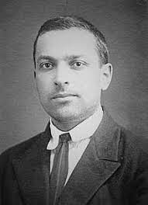
- Who is this theorist?
  - Lev Semyonovich Vygotsky, is a Russian psychologist, who is best known for his Sociocultural Theory.
- Where/when did they live and work?
  - He was born in Orsha, Russian Empire. 1896-1934.
  - He worked at Moscow’s Institute of Psychology
- What is their theory about play? What implications does this have for education?
  - Play as a Zone of Proximal Development (ZPD)
  - He believed that the ZPD is created through play and children could operate at their highest possible cognitive level in play.
  - He stressed the importance of the social nature of learning through play.
  - The creation of imaginary situations, pretend play, is the central element of Vygotsky’s theory.
  - Vygotsky’s play theory differs from other play theories because he focused on children’s dramatic or make-believe play which includes some components such as creating an imaginary situation, taking on and acting out roles, and following a set of rules.
  - He also believed that language is the greatest tool to learn, and children have introduced to learn language through play.
- Where can I learn more?
  - Mind in Society (1978)
  - Thought and Language (1934)
  - Play and Its Role in The Mental Development of the Child (1933)
  - Imagination and Creativity in Childhood (1927)

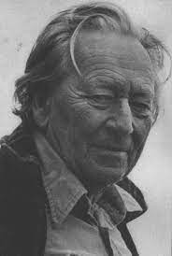
Theorist: Gregory Bateson
- Who is this theorist?
  - Gregory Bateson was an English anthropologist, social scientist, and linguist.
- Where/when did they live and work?
  - He was born in Grantchester, U.K. 1904-1980.
  - He taught at different universities such as the University of Sydney, Saybrook University, and the University of California.
- What is their theory about play? What implications does this have for education?
  - Play frames – events in play relate to real world
  - Bateson's attempt to understand play and conceptual frames was greatly influenced by his psychotherapy technique.
  - According to him, play is an exploratory behavior that allows to try out potentially dangerous situations without taking extreme risks.
  - He suggests that play itself creates its own frame, which establishes a context in which certain behaviors.
- Where can I learn more?
  - Steps to an Ecology of Mind (1972)
  - Mind and Nature (1979)
  - A theory of play and fantasy (1955)

Theorist: Jerome Bruner
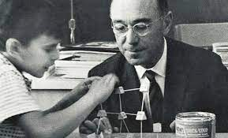
- Who is this theorist?
  - Jerome Seymour Bruner was an American psychologist and educator who worked on cognitive psychology.
- Where/when did they live and work?
  - He lived in New York, U.S. 1915-2016.
  - He began his academic career as a psychology professor at Harvard University and later retired from New York University Law School.
- What is their theory about play? What implications does this have for education?
  - Play as a way to practice and learn problem-solving strategies.
  - According to him, play provides an opportunity for children to take risks without fearing of failure.
  - He believed that learning is an active process and play creates an environment for children to explore and experiment.
  - His theory suggests that play allows us to modify the environment according to our desires, whereas learning allows us to better transform ourselves in order to fit the world's structure.
  - He believed in the social nature of learning in which adults should be involved in the learning.
- Where can I learn more?
  - Play, Thought, and Language (1983)
  - The process of education (1960)
  - Play: Its Role in Development and Evolution (1985)

Theorist: Mildred Parten
- Who is this theorist?
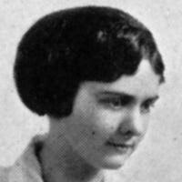
  - Mildred Bernice Parten Newhall was an American sociologist who is known for her stages of play.
- Where/when did they live and work?
  - Parten lived in Minneapolis, U.S. 1904 -1970.
  - She completed her doctoral dissertation in 1929 and she developed the theory of six stages of play in her dissertation by observing children’s free play.
  - She worked as a researcher at the Institute of Child Development at the University of Minnesota.
- What is their theory about play? What implications does this have for education?
  - Parten identified six stages of play (unoccupied, solitary, onlooker, parallel, associated, cooperative play) that children pass through.
  - Parten tried to explain how children interact with each other and a model of socialization skills during play in her stages of play theory.
  - Children move from unoccupied to cooperative play stages one by one from birth to middle childhood.
  - According to Parten’s theory, adults (parents and teachers) observe mostly parallel and associative play during toddler years.
  - The association is more important than the play activity itself in associative and cooperative play which is the most sophisticated form of play.
- Where can I learn more?
  - Social play among preschool children (1933)
  - Social Behavior of Preschool Children (1943)
  - Family income and expenditure in four urban communities of the Pacific Northwest (1939)

Theorist: Tina Bruce
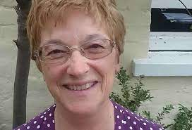
- Who is this theorist?
  - Tine Bruce is an Honorary Professor of Early Childhood Education and a theorist in the area of play-based learning in early childhood education.
- Where/when did they live and work?
  - Bruce was born in 1947, U.K.
  - Tina Bruce is a Professor of Early Childhood Education at the University of Roehampton. She is also a co-founding director of the Centre for Early Childhood Studies at the Froebel College, Trustee of the Froebel Trust.
- What is their theory about play? What implications does this have for education?
  - She introduced 12 features of play relating to the quality of play, rather than believing that play progresses through stages or sequences.
  - Instead of believing that children learn through play, she claimed that children use it to practice what they have previously learned and to test their ideas.
  - In 12 features of play, she suggests important features of play such as first-hand experiences, making rules, making and adapting play props, playing cooperatively, pretending, having personal agenda, coordinating ideas, and testing recently acquired skills.
  - Bruce claims that adults should facilitate play but not be responsible for it. Children should be provided a free-flowing form of play.
- Where can I learn more?
  - Time to Play in Early Childhood Education (1991)
  - Learning Through Play: For Babies, Toddlers, and Young Children (2011)
  - Helping Young Children to Learn Through Play (2001)
  - Quality of Play in Early Childhood Education (1996)

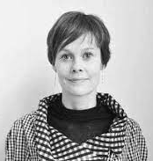
Theorist: Helle Marie Skovbjerg
- Who is this theorist?
  - Helle Marie Skovbjerg is Denmark´s first professor in play and a part of Design School Kolding's, in collaboration with the LEGO Foundation.
- Where/when did they live and work?
  - Skovbjerg was born in Denmark.
  - She introduced the idea of Play Moods which aim to capture that special way of being when you play.
- What is their theory about play? What implications does this have for education?
  - She developed the idea of play moods; devotion, intensity, tension, and euphoria.
  - In a devotional mood, there is no hardness in the body, only attention and focus, and the body is frequently quiet or moving slowly.
  - The intensity of play mood refers to extreme physical play situations, such as swinging, sliding, and riding a rollercoaster.
  - The third type of play mood is the tension which is defined by being ready to show yourself while also being aware of others.
  - The euphoria is the last type of play mood, which is characterized by an expectation of silliness. This type of play mood is also the most open-minded mood because of constantly seeking new meanings.
- Where can I learn more?
  - Playful learning, space and materiality: An integrative literature review (2022)
  - Play Tarot Cards: A method to explore play qualities in teaching using playful approaches (2022)
  - Supporting Play Pedagogy in Schools (2021)
  - Designing for Play Moods in a Ludotorium (2020)
  - The Future of Play (2020)

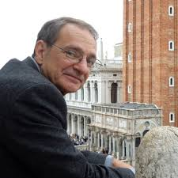
Theorist: William Corsaro
- Who is this theorist?
  - William Corsaro is a social psychologist who developed the idea of peer culture and play talks by investigating children’s interactions with peers and adults in schools and families.
- Where/when did they live and work?
  - Corsaro was born in 1948, in Indianapolis, U.S.
  - He was a Professor of Sociology at Indiana University, Bloomington and he has taught many courses on childhood socialization and childhood and society.
- What is their theory about play? What implications does this have for education?
  - Corsaro defines children’s peer culture as a stable set of activities or routines, artifacts, values, and concerns that children produce and share in interaction with each other.
  - Two fundamental elements emerge from his study of children's peer cultures: children make continual attempts to take control of their life and to share that power with each other.
  - According to Corsaro, children are always engaged in and a part of two cultures: children's and adults', and both cultures are intricately intertwined in many ways.
  - He stated that children did play alone or engaged in parallel play rarely because they were soon doing things together.
- Where can I learn more?
  - We're Friends, Right? Inside Kids' Culture (2003)
  - The Sociology of Childhood (2017)
  - Spontaneous Play and Social Learning in the Nursery School (1980)
  - Peer Play and Socialization in Two Cultures: Implications for Research and Practice (1991)

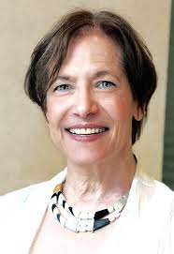
Theorist: Kathy Hirsh-Pasek
- Who is this theorist?
- Kathy Hirsh-Pasek is a U.S. psychologist whose research focuses on learning through play and guided play.
- Where/when did they live and work?
  - At Temple University in Philadelphia, PA, USA. She is also a Senior Fellow at the Brookings Institution.
- What is their theory about play? What implications does this have for education?
  - Hirsh-Pasek and colleagues’ research demonstrates the power of learning through play for young children. They have found that play supports learning across domains
  - The concept of guided play has been elaborated by Hirsh-Pasek and colleagues. In guided play, children take the lead, while an adult facilitates the learning experience by scaffolding with language, materials, and questions.
  - Hirsh-Pasek’s work has contributed to advocacy efforts to increase play and playful learning for children within and beyond school contexts.
- Where can I learn more?
  - Hirsh-Pasek’s website has links to many of her published research and reports: https://kathyhirshpasek.com/play/

Theorist: Add your own!
- Who is this theorist?
  - Add here
- Where/when did they live and work?
  - Add here
- What is their theory about play? What implications does this have for education?
  - Add a short paragraph here
- Where can I learn more?
  - Link to a resource

