Playful Learning Idea Generator

How can we support academic content learning through play (fostering choice, wonder, delight)?

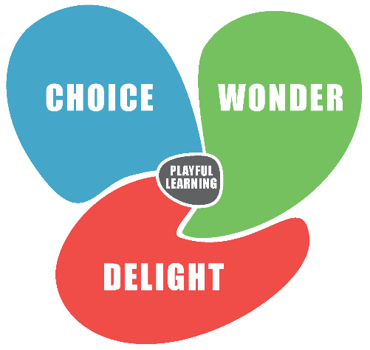
- Introduce play in different ways
(why? what is playful to one isn’t always playful to another)

  - Introduce novel materials connected to your learning goals
  - Embed making mistakes, playful trickery, secrecy, or the unexpected in the learning experience
  - Use fantasy, storytelling, or pretense to engage children’s imaginations
  - Create private learning spaces or artifacts “with a twist” (e.g., a reading tent, a creative corner)
  - Collaborate with specialists to connect to other subject matter (e.g., the arts, physical education, etc.)

- Provide different levels of choice
(why? children’s motivation increases when they have a sense of agency)

- Turn things over to children that you would typically do yourself (e.g., invent a clean-up song, choose where to sit). Let your key learning goals determine when and how to follow children’s lead.
- Pursue questions without predetermined answers
- Give children choice with regard to:
  - content (what are we learning?)
  - process (how are we learning it?)
  - product (how can we show what we know?)

- Keep your learning goals visible and in the foreground
(why? with increasing choice, play can sometimes stray from learning goals)

- Make children’s thinking and learning visible to create a memory for the group
- If you introduce novel materials, choose materials connected to your learning goals
- Invent (with children) playful language to inspire learning (e.g., Wonder Walls, Bubble Catchers)
- Keep learning goals or ideas visible with increasing freedom (e.g., create or share a rubric)

- Invite connections between the classroom and the world
(why? understanding is supported when learning is transferred to a new context)

- Engage children and/or adults in role play
- Connect the interests children demonstrate in Passion Day to classroom learning
- Communicate with families and ASC teachers about learning goals and children’s interests
- Build in an action component that connects the learning to the outside world (e.g., find an audience for an end-of unit task or a practical application)

- Create, or work with children to create, reflection prompts and routines
(why? “We do not learn from experience; we learn from reflecting on experience.” ~Dewey)

- Invite children to evaluate a session with regard to playfulness and learning and make suggestions
- Collaborate with children on the wording for reflection prompts
- Ask children in advance of a unit how they would like to share their learning with others
Playful Learning Idea Generator

How can we support academic content learning through play (fostering choice, wonder, delight)?

Please fill in one or more boxes with your ideas!

- Introduce play in different ways

(why? since what is playful to one isn’t always playful to another)
Embed making mistakes, playful trickery, secrecy, or the unexpected in the learning experience

Introduce novel materials connected to your learning goals

Collaborate with specialists to connect to other subject matter (music, drama, visual arts, physical education)
Create private learning spaces or artifacts “with a twist” (e.g., private “Bubble Catcher” journals for recording ideas so they don’t float away, a reading tent, a creative corner)

Use fantasy, storytelling, or pretense to engage children’s imaginations
Playful Learning Idea Generator

How can we support academic content learning through play (fostering choice, wonder, delight)?

- Provide different levels of choice

(why? children’s motivation increases when they have a sense of agency)

Pursue questions without predetermined answers
Turn things over to children that you would typically do yourself (e.g., invent a clean-up time song, choose where to sit, etc.). Let your key learning goals determine when and how to follow children’s lead.

Give children choice with regard to:
- content (what are we learning?)
- process (how are we learning it?)
- product (how can we show what we know?)
Playful Learning Idea Generator

How can we support academic content learning through play (fostering choice, wonder, delight)?

3. Keep your learning goals visible and in the foreground
(why? with increasing choice, play can sometimes stray from learning goals)

Make children’s thinking and learning visible to create a memory for the group

Invent, or collaborate with children to invent, playful language to inspire learning (“Wonder Walls,” “Bubble Catchers,” etc.)

Keep learning goals or ideas visible with increasing levels of freedom (e.g., create or share a rubric, K3 rules bracelet)

If you introduce novel materials, choose materials that are connected to your learning goals

Playful Learning Idea Generator

How can we support academic content learning through play (fostering choice, wonder, delight)?

- Invite connections between the classroom and the world

(why? understanding is supported when learning is transferred to a new context)

Engage children or adults in role play

Connect the interests children demonstrate in Passion Day to classroom learning

Communicate with families and ASC teachers about learning goals and children’s interests
Build in an action component that connects the learning to the outside world, e.g., find an audience for an end-of-unit task or a practical application

Playful Learning Idea Generator

How can we support academic content learning through play (fostering choice, wonder, delight)?

5. Create, or work with children to create, reflection prompts and routines

(why? “We do not learn from experience; we learn from reflecting on experience.” (Dewey)
Invite children to evaluate a session with regard to its playfulness and learning and to make suggestions for the future (e.g., fill out a playful learning graph)

Collaborate with children on the wording for reflection prompts

Ask children in advance of a unit how they would like to share their learning with others

